# Ch 3 Project management

To achieve specified goals within predetermined restrictions like time, budget, and scope, project management is the activity of planning, coordinating, and supervising the execution of a project from beginning to end. It entails the use of information, skills, tools, and procedures to manage resources, tasks, risks, and stakeholders efficiently to produce successful results. (PMI)

## Process Model

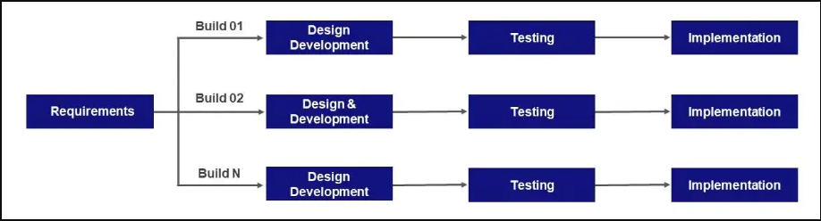

*Figure 3.1: Incremental Process Model*

Figure 3.1 shows the process model for our system, which is the incremental process model.

A software development strategy known as the incremental model divides project requirements into independent modules or increments. With the intention of delivering a fully working release at the end of each iteration, each module is independently designed, developed, tested, and implemented. The software can be gradually updated with new features and functionalities thanks to this iterative method.

In the incremental strategy, the initial release usually concentrates on the fundamental needs and core functionality of the project. This makes it possible for the speedy delivery of a functional product that can be used by end customers and put into production. Then, later iterations add to the prior releases by giving the software new features and improvements.

The incremental model was chosen due to the advantages it has that help us develop the software. These advantages include the following:

* It helps to identify the errors easily.
* Simpler in testing and debugging.
* With more rapid delivery, it is possible for the client to get the main functionality early.
* It is easier to get feedback from customers on the development work that has already been done.
* The cost of changing requirements is reduced and more flexible.
* Phases are organized and well-structured, and it is user-friendly, easy to use, and easy to understand.

The phases of the incremental process model will be as follows:

* Requirement analysis: Requirement analysis is the first phase of the incremental process model, which focuses on requirements gathering and analysis, the main objective is to understand what needs to be designed and define its functions, purpose, and other relevant aspects.
* Design and Development: In this phase of the incremental model, which follows the initial requirements analysis phase, the focus is on the design and development of the system's functionality. The goal is to convert the analyzed and documented requirements into modules and prototypes. When new functionality is introduced to software, the incremental model takes advantage of style and creation processes to efficiently incorporate new features or functionality into the existing software system.
* Testing: After completing the design and development process, in this phase of the incremental model, the performance of all current features and functions is evaluated to ensure their effectiveness and efficiency.
* Implementation: During this phase, the software development process begins by utilizing the collected data from previous phases. It involves the implementation of the software using the gathered information and incorporates the testing of features during the subsequent testing phase. The number of the product working is improved and upgraded up to the final system product after this phase is complete.

## 3.2 Risk Management:

Software risk management is important in software engineering for project success. It involves identifying, addressing, and mitigating potential problems, prioritizing them, developing a well-structured plan, monitoring for risk triggers. By implementing these practices, software projects can proactively address challenges and increase the possibility of success. (EPAM Solutions Hub ,2022)

## 3.2.1 Risk Identification:

There are three main categories of software project risks:

1. **Project Risks:** In software engineering, risks encompass various aspects such as scheduling, personnel, resources, and customer-related concerns. (javatpoint, 2018)
2. **Technical risks:** It is considered the risks that are related to implementation and testing, as well as the issue of maintenance and potential methods, and appears for several reasons, including the extent of the knowledge of the project development team.

(javatpoint, 2018)

1. **Business risks:** It is the risk of creating an unsuitable and unused product that is not wanted by society. And this results in a loss in budget or staff. (javatpoint, 2018)

## Risk Analysis:

The table below was created to examine the potential risks to determine the amount of the project's risk exposure.

|  |  |  |  |  |
| --- | --- | --- | --- | --- |
| Risk Type | Risk Description | Probability | Impact | Mitigation Strategy |
| Project | Changing Requirements | Medium | Tolerable | Create a change management procedure, then document the modifications. |
| **Project** | Team member loss | Low | Tolerable | Replace him/her with another. |
| **Project** | Time management scheduling | High | Serious | Create a complete project plan and divide tasks into units. And make sure to track the progress. |
| **Technical** | Compatibility problems with various devices and browsers. | Low | Tolerable | Test site on multiple browsers for enhanced compatibility |
| **Technical** | Missing Requirements | Low | Tolerable | Get the customer's feedback. |
| **Technical** | Problems with site functionality, not work probably. | High | Serious | Identify the problems, then redevelop. |
| Organizational | inadequate project team skills and resources | Medium | Serious | Conduct training and recruit additional resources |

## 3.3 Project Activities Plan:

The project activities plan defines each project activity or task along with the estimated time required for its completion. This plan serves as a roadmap for project members, enabling them to break down the project into smaller tasks. By monitoring the progress of these activities, the plan ensures that the project stays on track and achieves its goal within the agreed-upon time frame.

In order to organize the tasks for this project, we utilized Microsoft Project software to create the Gantt Chart. The chart, displayed in figure 3.2, outlines all the planned activities.

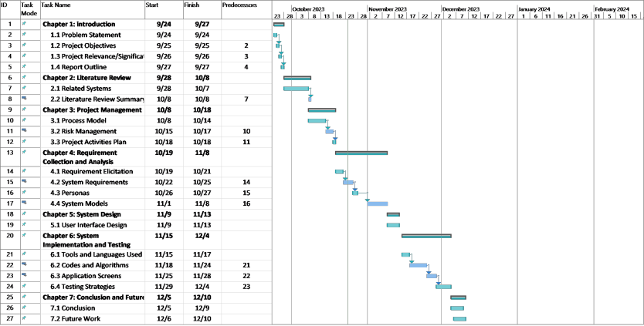

*Figure 3.2: Gantt Chart*

## References:

* Project Management Institute (PMI) n.d., Project Management Institute, viewed 10 October 2023, <https://www.pmi.org/>.
* EPAM SolutionsHub (2022), 'Risk Management in Software Engineering', viewed 11 October 2023, <https://solutionshub.epam.com/blog/post/risk-management>.
* javatpoint (2018), 'Incremental Model', viewed 14 October 2023, <https://www.javatpoint.com/software-engineering-incremental-model>.